**1. Main user interface screen:**

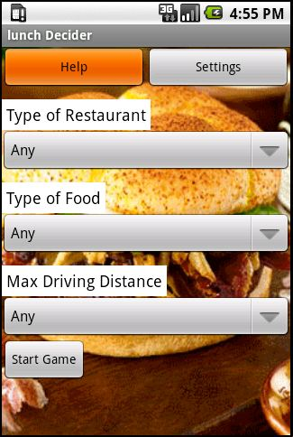

Figure 1: Main Input Screen

This is the first screen appears when user opens the application. Where he inputs type of restaurant, type of food, max. Driving distance as the input.

**2. Help Screen**

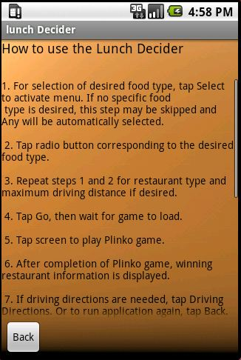

Figure 2: Help Screen

This screen provides the information of how to use the lunch decider application.

**3. Settings Screen**

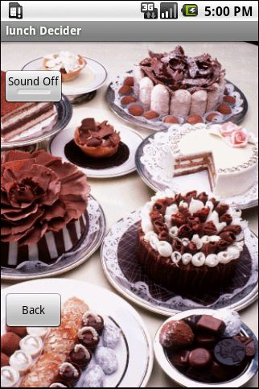

Figure 3: Display Settings

This provides features such as sound on and sounds off.

**4. Searching User Location:**

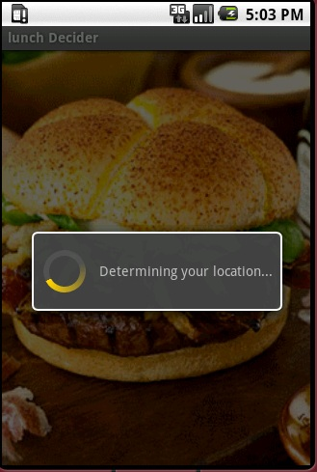

Figure 4: Determining User Location

After user enters the input criteria and hits the start game button then our application will determine for user location and provides restaurants according to user location.

**5. Location Not Found:**

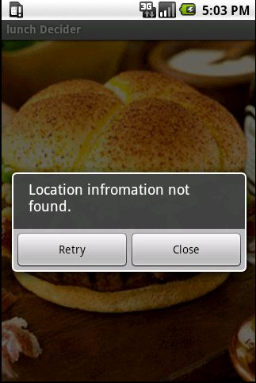

**Figure 5: When User Location Not Found**

User location information is not found when GPS could not be able to return the results.

**6. Internet Connection is Disabled:**

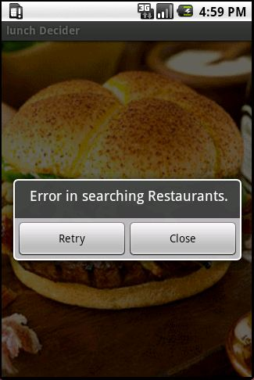

Figure 6: Error in Finding Restaurants

When the internet connection is not there or disabled lunch decider application cannot return any search results and displays error in searching restaurants.

**7. Restaurants Not Found:**

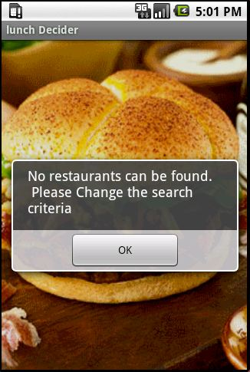

Figure 7: Restaurants Not Found for User Input Criteria

No restaurants can be found if the search criteria do not meet any of the data in database and displays the message in figure7.

**8. Plinko Game:**

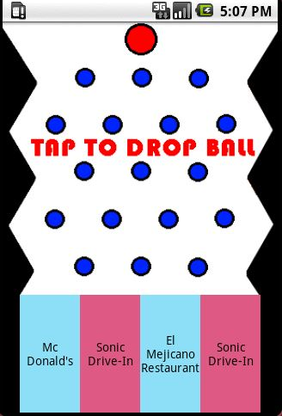

Figure 8: Plinko Game Design

This is the game that we used to select the winning restaurant by using Plinko.

**9. Picking Winning Restaurant:**

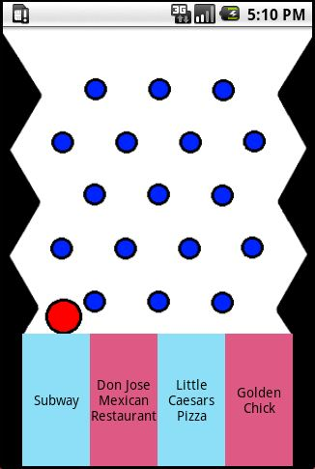

Figure 9: Winning restaurant Found

After playing the game the ball will be landed in one of the restaurant and that is the winning restaurant for our lunch decider application.

**10. Name and address of Winning Restaurant:**

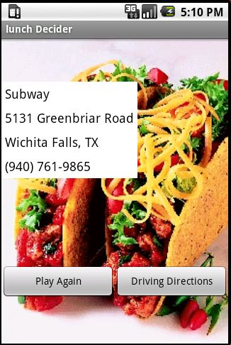

**Figure 10: Winning Restaurant Address**

Winning restaurant is name and address are displayed from this screen if user want to play the game again he can play or else he can get the driving directions to that restaurant.

**11. Direction Map**

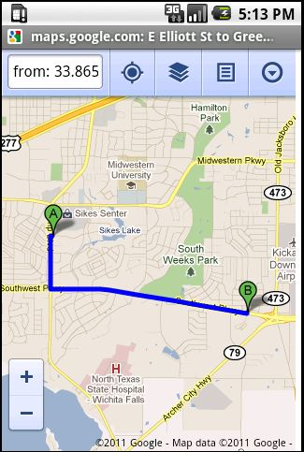

**Figure 11: Direction to the Restaurant**

After clicking on driving direction the application will be directed to google maps where the path to the restaurant is displayed.